**Usability Testing:**

|  |  |  |  |  |
| --- | --- | --- | --- | --- |
| **No** | **Title** | **Test Steps** | **Expected Result** | **Actual Result** |
| 4.1 | System UI Usability | Search something from search bar | Search result will be shown | Search result shown |
| 4.2 | UI Usability Test | Checking text, navigation bar, dropdown etc. | All these components Will be shown properly for users. | Navigation bar, dropdown menu showing properly. |

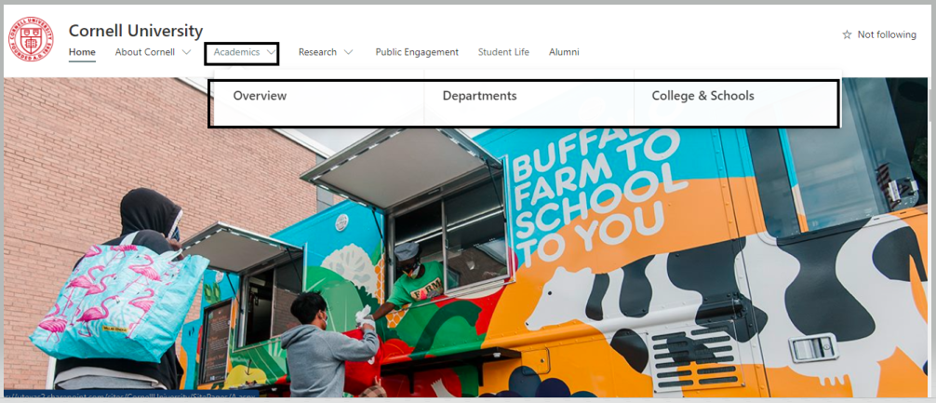

Figure : Dropdown menu

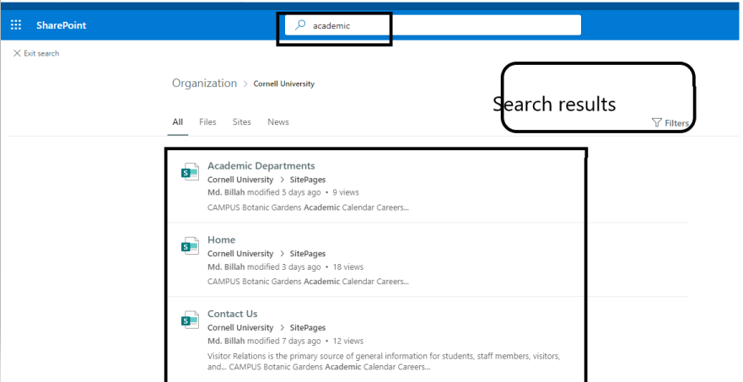

Figure : Showing search results.